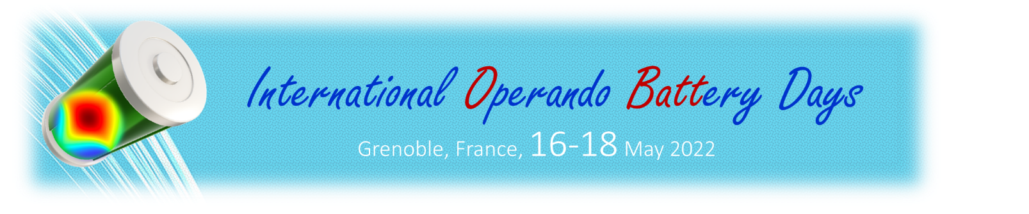
YOUNG SCIENTIST AWARD APPLICATION FORM

NAME :
AFFILIATION :
PhD DEFENSE DATE :

MAIN TOPIC of research
Summary of your scientific activities and focus (do not exceed the box)

OPERANDO CHARACTERIZATION OF BATTERIES : YOUR VISION
Your personal viewpoint : how do you envision research in the field of operando characterization of batteries by 2030 ? Challenges, bottlenecks, opportunities ? (do not exceed the box)

EXTENDED CV
Please provide an extended CV containing education, professional experience, list of 10 major publications, prizes and grants.
[3 pages max]

